Pf lab 6 screenshots



1. 

3

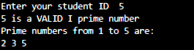

4

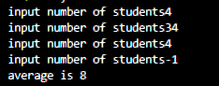

5

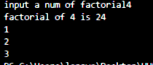

6

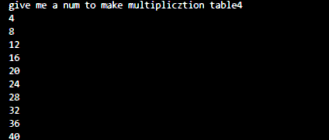

7



8



9

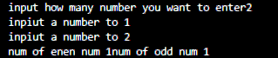

10

